FPT International School
--- o0o ---

PROJECT REPORT
<Insurance>
Batch: T2303E
Semester: HKI
Group: 4 Glasses Guys
Member :Nguyễn Văn Lưu -TH2302034
Nguyễn Hữu Nghĩa -TH2302010
Nguyễn Hữu Hoàng Viên -TH2302026
Hanoi - 08/2023

Table of Contents
1. Problem Definition 3
i. Introduction 3
ii. Implementation Environment 3
User Stories 4
1.2 User type 1 4
i. Story 1 4
ii. Story 2 4
iii. Story 3 4
1.3 User type 2 4
i. Story 1 4
ii. Story 2 4
2. Database 5
2.1 DB Relationship Diagram 5
2.2 Table 1 (company) 5
2.3 Table 2 (product) 6
2.4 Table 3 ( Product_detail) 6
2.5 Table4(contact) 6
3. UI\UX 7
3.1 GUI 1 (Homepage) 7
3.2 GUI 2 (Product) 7
3.3 GUI 3 (Search) 8
3.4 GUI 4 (Contact) 8
3.5 GUI 5 (Register form) 9
4. Summary 10

Problem Definition

Introduction
The insurance always important in my life .
However, the work schedule is busy, the location is far away, and there is no convenient means of transportation time slots pose as major barriers when applying concepts to realism. And so it is necessary to look for alternative means of performance in ladder approach. The above really place special restrictions on our students! With their busyness schedule, is really difficult for our students to keep up with genuine and. The constant need for integrated applications can be seen directly, especially in IT education field where technology can change rapidly.
technology will help us at such times!!

Implementation Environment
Code storage : Git - hub
Front - End : HTML, CSS, EJS
Backed - End : EXPRESS, NodeJS, Javacripts, My SQL server.
User Stories

User type 1
i. Customer can go in the website and will be welcome by a homepage that is divided into sections with a search bar and information to catch user’s attention.
ii. Users can browse through insurance plans categorized by the type of vehicle they're driving, or they can simply choose a or select available insurance plans.
iii. After choosing a plan , they can see detailed information and what they need to pay attention to when signing up . After registering they can see additional support and terms to pay attention to after registration

User type 2
i. Student users will be greeted by the homepage and can use the search bar to quickly find what they are looking for
ii. From there they can quickly view information after searching .

Database

DB Relationship Diagram

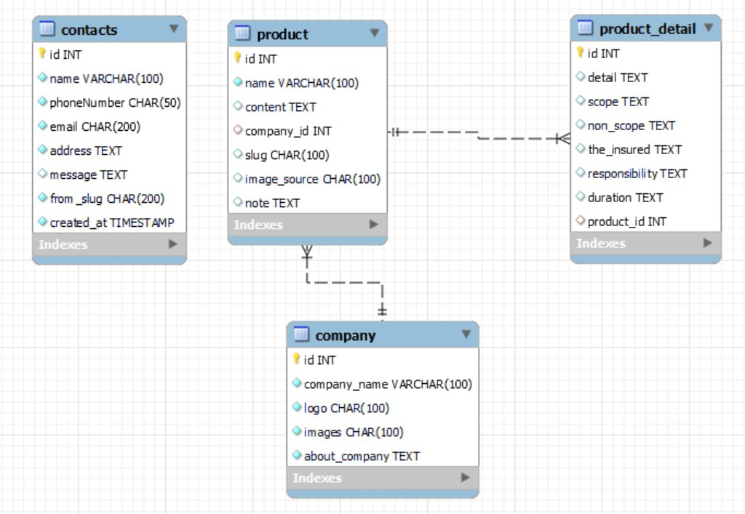

Table 1 ( Company)
Column Name | Data Type | Constraint | Description
id | INT | PK | Primary key of the table
Company_name | Varchar(100) | Not null | Status of the company
Logo | Char(100) | Not null | Logo
Image | Char(100) | Not null | Image
About_company | Text | Not null | About_company

Table 2 (Product)
Column Name | Data Type | Constraint | Description
Id | int | PK | Primary key of the table
name | Varchar(100) | Not null | Name product
content | Text | Not null | content
Company_id | Int | FK | Foreign key of the table
Slug | Char(100) | Not null | Path to page
Image_source | Char(100) | Not null | Image
note | text | Not null | note

Table 3(Product_detail)
Column Name | Data Type | Constraint | Description
Id | INT | PK | Primary key of the table
detail | Text | Not null | Status of the product
scope | Text | Not null | Scope in the product
non_scope | Text | Not null | Non-Scope in the product
The_insured | Text | Not null | The insured
responsibility | Text | Not null | responsibility
duration | Text | Not null | Enjoyment time
Product_id | INT | FK | Foreign key ò the table
created_at

Table4(Contact)
Column Name | Data Type | Constraint | Description
Id | Int | PK | Primary key of the table
name | Varchar(100) | Not null | name
phoneNumber | Char(50) | Not null | phoneNumber
email | Char(200) | Not null | email
address | Text | Not null | address
messenger | Text | Not null | messenger
from_slug | Char(200) | Not null | from_slug
Product_id | timestamp | Not null | create_at

UI\UX

GUI 1 (Homepage)

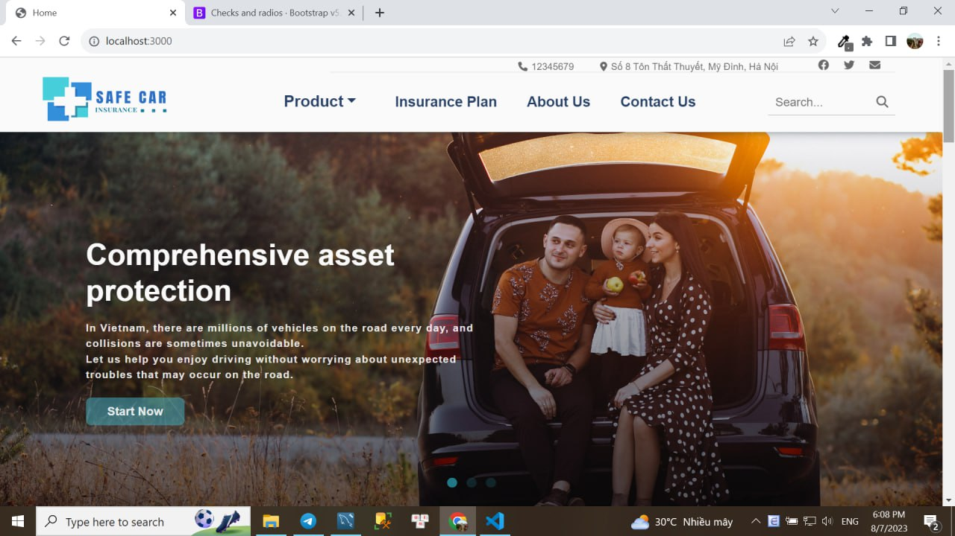

GUI 2 (Product)

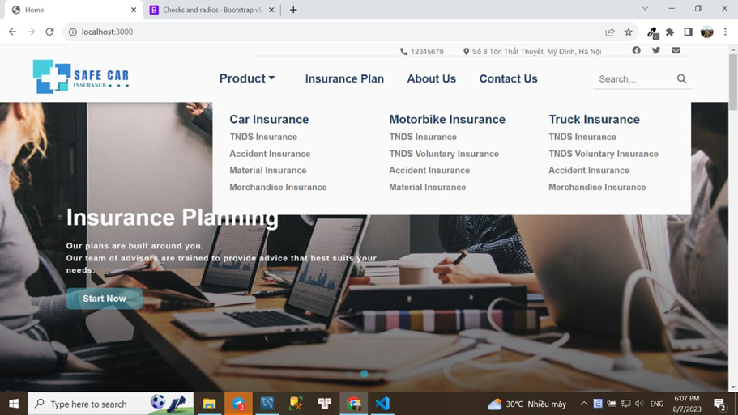

GUI 3(Search)
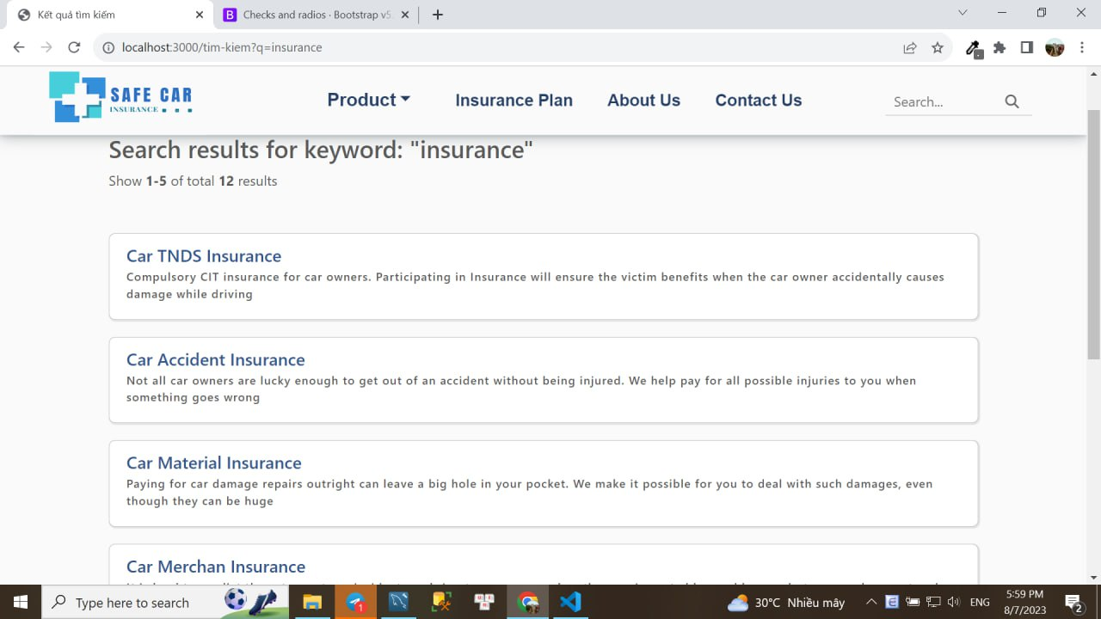

GUI4(Contact)
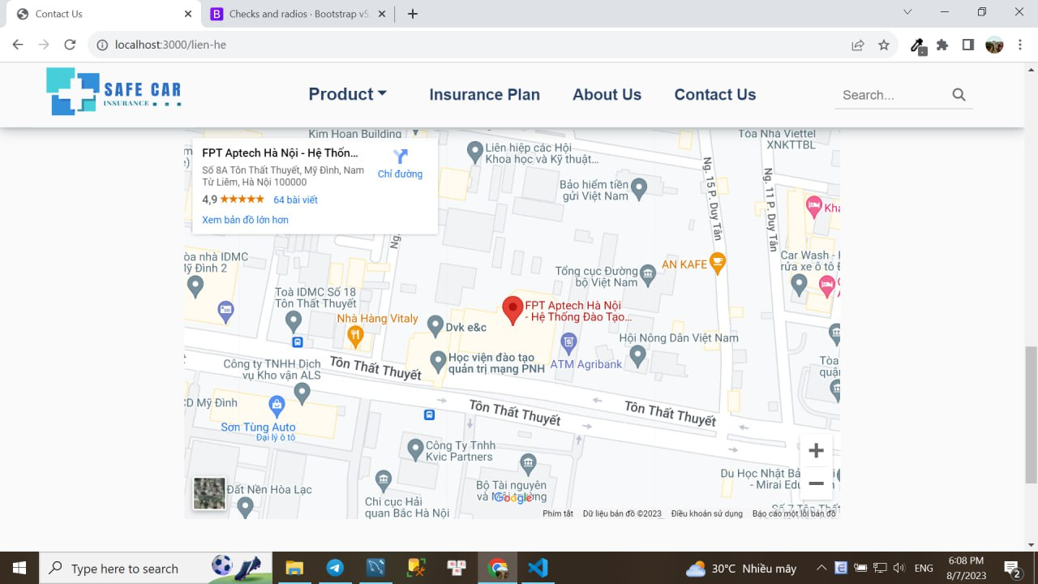

Gui5(Register form)

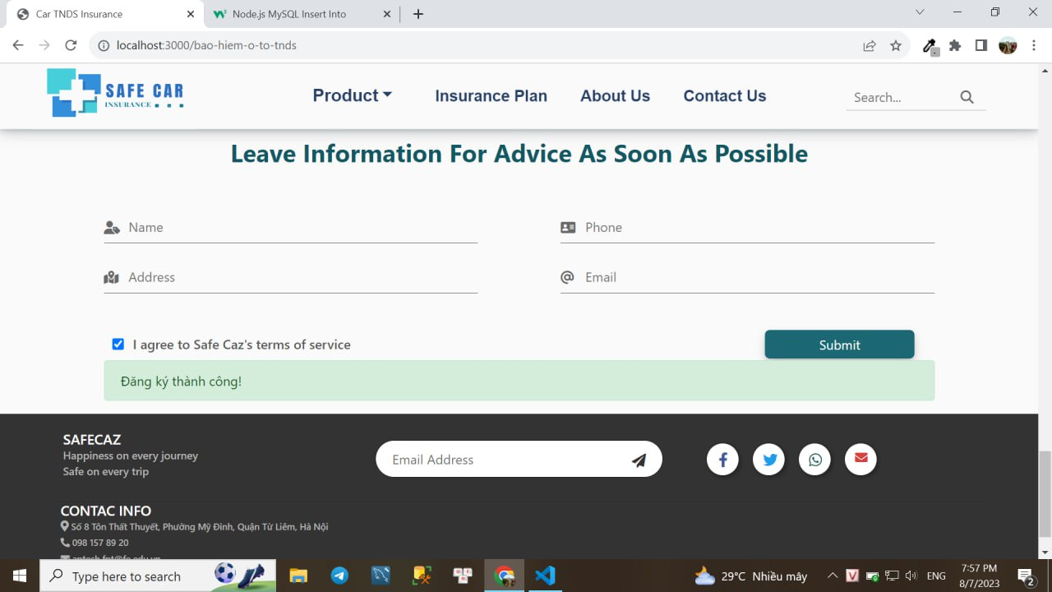

insertDb of register form

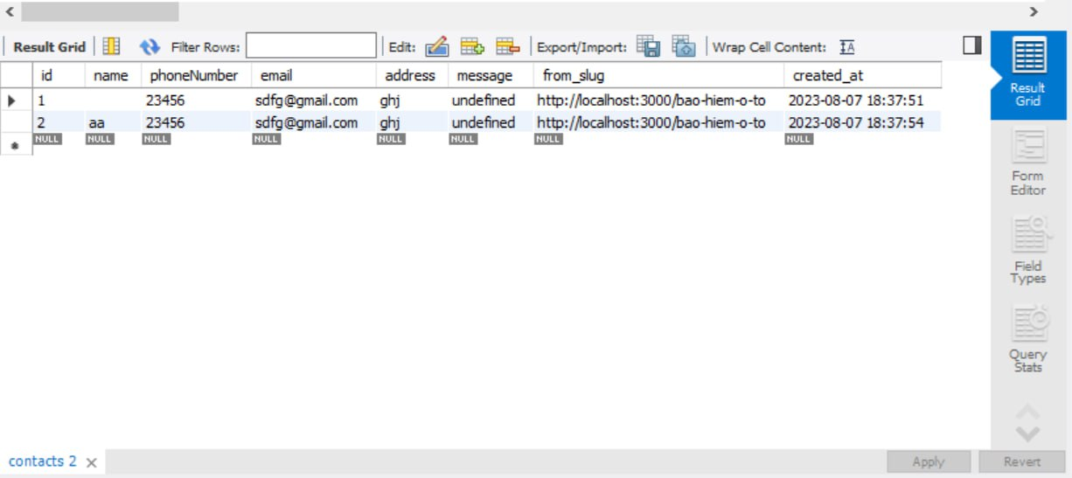

Validation of register form

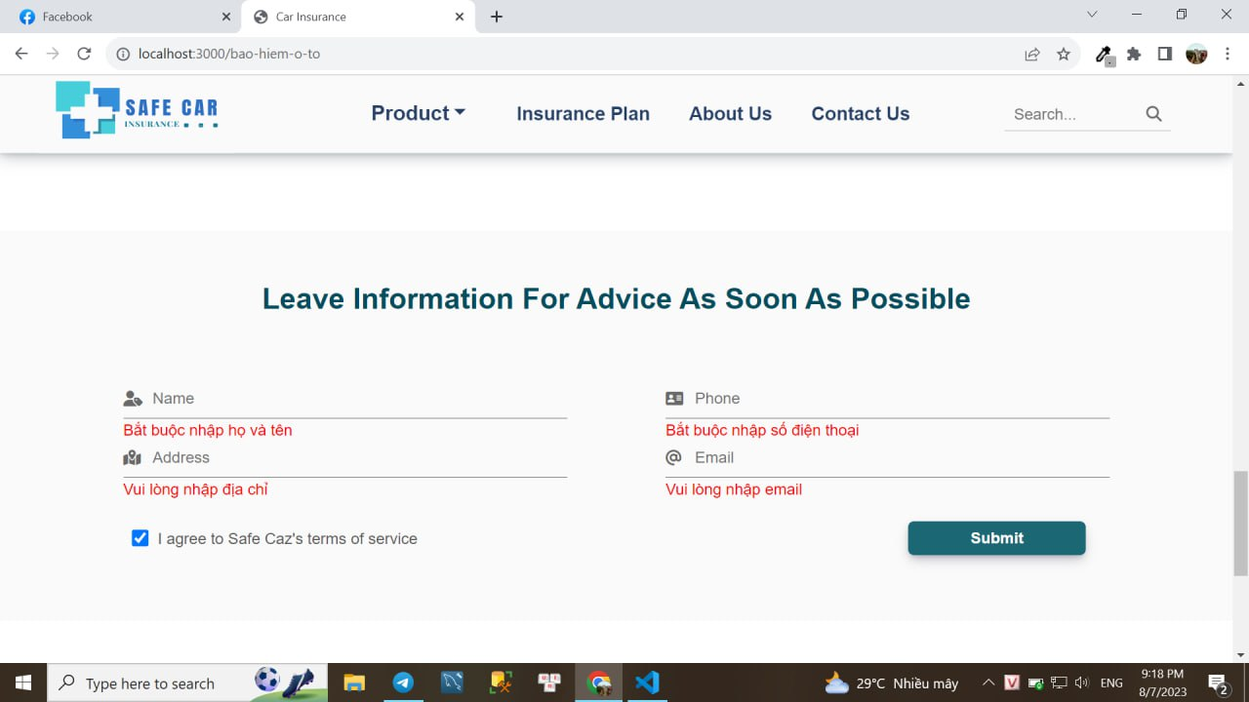

Summary
However, the work schedule is busy, the location is far away, and there is no convenient means of transportation time slots pose as major barriers when applying concepts to
realism. And so it is necessary to look for alternative means of performance in
ladder approach.
The above really place special restrictions on our students! With their business
scheule, is really difficult for our students to keep up with genuine and
The constant need for integrated applications can be seen directly, especially in
IT education field where technology can change rapidly.
technology will help us at such times!!

Personal summary:

Throughout this project, I have learnt the skills to create a website that is good to look at, to put myself in the shoe of a customer/client who with or without a purpose access the website looking for information or just simple browse. Using those skills, with the usage of HTML, NodeJS, EJS, Express, CSS, JS and framework other . I have created a website that can catch the attention of the viewer and provide all the necessary tools for the user to navigate throughout the page looking for the information they need and make it very simple for them to be able to contact the website management company. I have also learnt a lot of things about how a relational database work as well as the workflow and communication between front-end side of things and back-end side of things. There is a thing that I can improve on that is team work, communication between teammates and get a better understanding of the team to divide work flow better and help everyone synchronize to work together and utilize git and git-hub to futher improve the efficiency of the team as member and a leader. - Lưu

